Eric Dasilva

Professor Sanford

CS 340

December 11, 2022

Project 2

## About the Project/Project Title

This projects purpose is to create a dashboard that will allow for a user to identify and navigate available pets for adoption. The client, Grazio Salvare, will be conducting this search in the Austin, Texas area. The main functions of the dashboard must include a data table that provides all pet information, a pie chart with the breed of pets, and finally a map with the pets location. The final addition to the project is to add a radio button as a filter that is able to identify the types of pets in accordance with Grazio Salvares requirements for service animals.

**Motivation**

The projects motivation is to query a database and provide information that is available to their customers.

**Getting started**

1. MongoDB setup

To start this set up the AAC data is imported into MongoDB by first opening the terminal window and starting mongo with authentication by using the command /usr/local/bin/mongo_ctl start. Next the data sets are loaded into the mongoDB server with the commands cd /usr/local/datasets , /usr/local/bin/mongod_ctl start-noauth , mongoimport --port ##### --db AAC --collection animals --type=csv --headerline ./aac_shelter_outcomes.csv. The screen shot below will allow a visual as to how this was done in the terminal.

1. The second step is to setup Admin and User privileges by starting with the command mongo –authenticationDatabase “admin” -u “Spartan123” -p. This set up the Admin user with admin privileges.

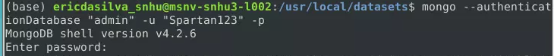

1. Next the command mongo –authenticationDatabase “AAC” -u “aacuser” -p which then added the user profile onto the database.

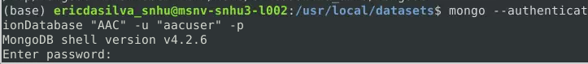

**Installing**

MongoDBCRUD.py and ProjectTwoDashboard.ipynb were added to the home directory.

**Usage**

The first point of usage is to select the radio button on the menu. The second is to update the map by selecting the radio button next to the row that is wanted to be displayed.

**Map and Graph**

The code below shows the data in the pie chart on the dashboard that is separated by breed. The map code shows the geolocation of the chart

**Table**

The code below shows all the queried values that match the required filter functionality mentioned.

**Radio Button**

This code is written to default to reset and then toggle between the options

**Logo**

The code below shows the addition of the Grazioso Salvare logo.

